WILLETTON SENIOR HIGH SCHOOL
Y11 PHYSICS

HEATING FUNDAMENTALS
TEST – 2019

45

Student Name: ________________________

Teacher (Please tick one box)
Dr Pitts G-1 □
Mr Dopson G-2 □
G-3 □
Mrs Munshi G-4 □
Mr Boughton G-5 □

Time: 1 Hour

NOTE:

- Calculations must show clear working with formulae.
- State your final answers to three significant figures.
- Marks may be allocated for clear and logical setting out
- State assumptions if working on open ended type questions.

- Write a brief statement (with reference to energy transfer) to explain each of the following observations. (2 marks each)
- The temperature inside a black car initially increases at a higher rate than the temperature inside a white car when left standing in the sun.

________________________________________________________________________________
________________________________________________________________________________
________________________________________________________________________________
________________________________________________________________________________
________________________________________________________________________________
________________________________________________________________________________
________________________________________________________________________________
________________________________________________________________________________

b) Inland daytime temperatures are usually higher than those at places near the coast.

________________________________________________________________________________
________________________________________________________________________________
________________________________________________________________________________
________________________________________________________________________________
________________________________________________________________________________
________________________________________________________________________________
________________________________________________________________________________
________________________________________________________________________________

c) In winter time, walking bare-footed across a tiled floor is much colder than walking on a carpeted floor

________________________________________________________________________________
________________________________________________________________________________
________________________________________________________________________________
________________________________________________________________________________
________________________________________________________________________________
________________________________________________________________________________
________________________________________________________________________________
________________________________________________________________________________

d) Using a damp cloth to remove a hot container from an oven may result in severe burns.

________________________________________________________________________________
________________________________________________________________________________
________________________________________________________________________________
________________________________________________________________________________
________________________________________________________________________________
________________________________________________________________________________
________________________________________________________________________________
________________________________________________________________________________

- You have been given a thermometer with a numbered graduated scale. Without using another known instrument for measuring temperature, explain how you would scientifically verify that the thermometer scale is in Celsius?
Answer the question in point form. (2 marks)

- For the following statements (1) to (4), select the option (A, B, C, D or E) which best describes its association with a method of heat transfer. (2 marks)

OPTIONS
A | Convection currents
B | Expansion of solids
C | Radiation
D | Conduction
E | Expansion of liquids

STATEMENTS |  | Selected option
1 | Hot air balloons.
2 | Operation of a mercury-in-glass thermometer.
3 | The bases of frying pans are sometimes made of copper.
4 | An aluminium window frame feels cold when you touch it on a cold day.
- A 65.0 g pellet of Noohopium metal is heated to 135ºC and is quickly placed into a 120 g glass beaker containing 320 g of water at a temperature of 25.0ºC. The final maximum equilibrium temperature is 30.9ºC (assume no heat loss). Specific heat of glass = 0.84 x 10³ J kg⁻¹ K⁻¹.
Determine the specific heat of the Noohopium metal. (4 marks)

- In making iced tea 1.75 kilograms of hot tea at 100ºC is cooled to 0.0ºC using a quantity of ice at 0.0 ºC. (The specific heat of ice tea = 4.18 x 10³ J kg⁻¹ K⁻¹)

(a) Show your work to determine whether or not 2.00 kilograms of ice added to the hot tea will achieve a final temperature of 0.0ºC. (3 marks)

(b) What is the final temperature achieved with adding 2 kilograms of ice? (3 marks)

(c) How much ice is required for the iced tea to achieve 0.0ºC? (2 marks)

- The diagram below shows a graph of temperature against time for a particular substance that has a mass of 0.2 kg which has been cooled at a constant rate of 2000J each second from a high temperature to a low temperature. Use the letters to answer the following questions and explain your answers. (5 marks)
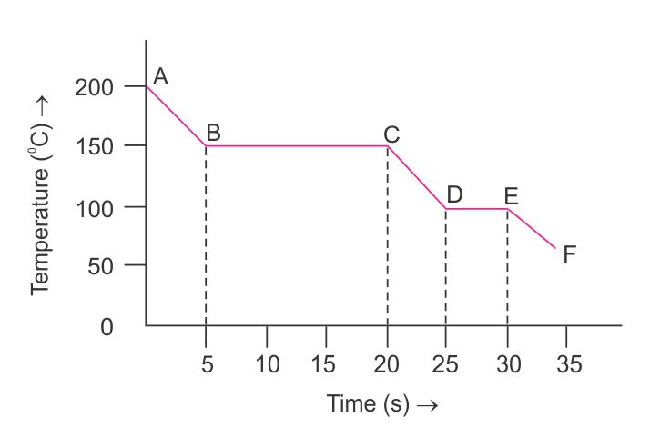

Question |  | Answer | mk
(a) | At which point is the substance completely solid. |  | ½
(b) | Which section, or sections, of the graph show the substance in two states at the same time. |  | ½
(b) | Explain your answer. |  | 1
(c) | Which section of the graph shows the liquid phase? |  | ½
(c) | Determine the specific heat of the liquid phase. |  | 1
(d) | At which point do the molecules of the substance have the largest average Kinetic Energy? |  | ½
(d) | Explain your answer. |  | 1
- Many farms use in ground dams to store water for livestock and other farming needs. The cross sectional diagram below shows the design and dimensions of an in ground farm dam that is full of water. (4 marks)
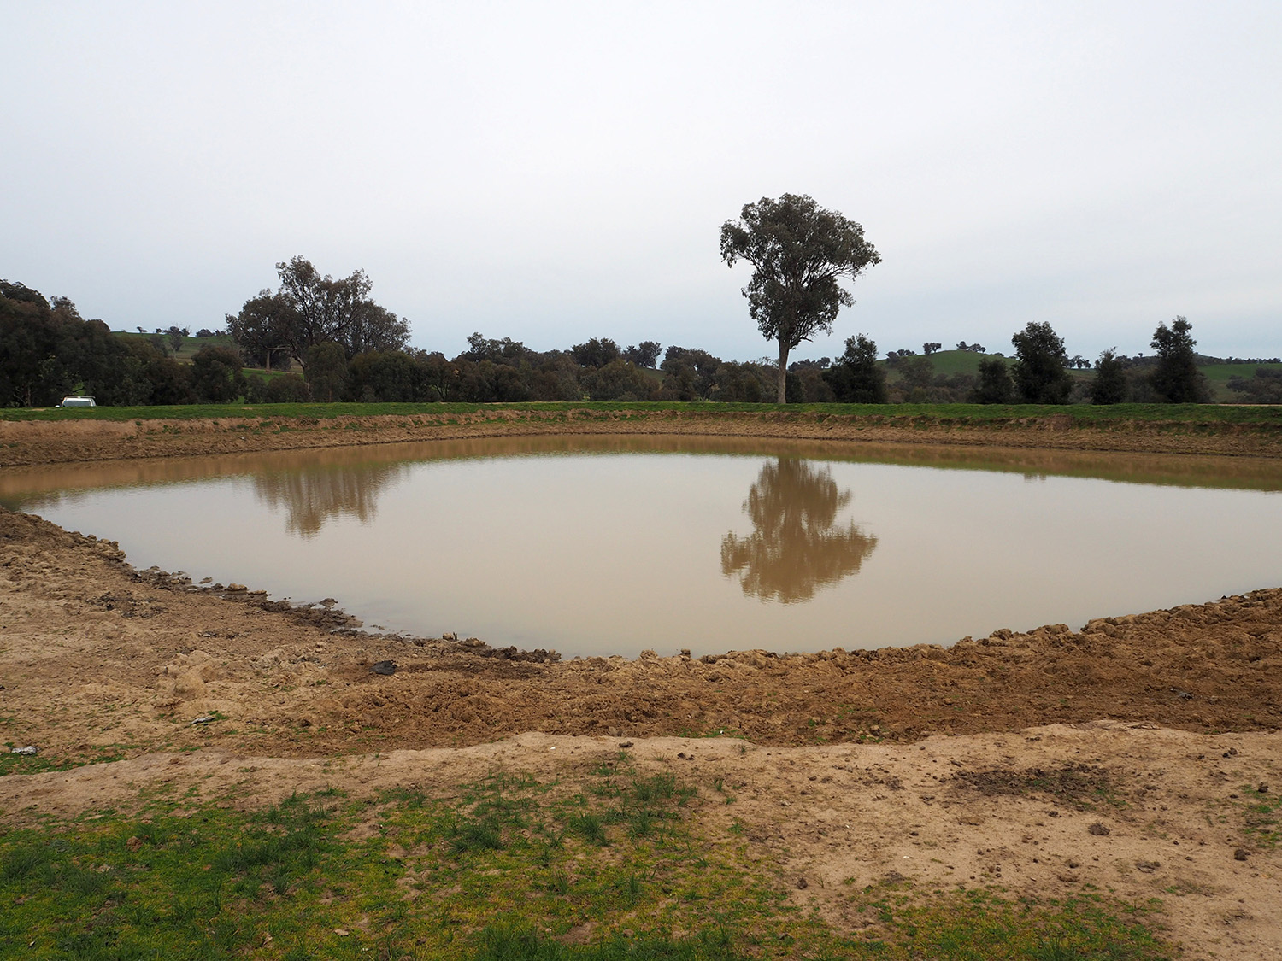

30 m
2 m
Water

Suggest 2 modifications (without cooling the water) to the design of the dam to help reduce the loss of water through evaporation.
Explain the purpose or reason for your modifications.

Modification 1

Reason

Modification 2

Reason

- Solar hot water systems convert electromagnetic energy from the sun to thermal energy in the water in the heater. How much solar energy does a solar heater need to absorb to raise the temperature of 165 kg of water from 22.0 °C to 85.0 °C? Assume that the system converts only 70% the solar energy to thermal energy of the water. (3 marks)

- On Master Chef a competitor pours 920g of soup at 95.0 °C into a 120g china bowl with a specific heat capacity of 1085 Jkg⁻¹K⁻¹. The soup raises the temperature of the china bowl from 22.0 °C to 82.0 °C. Determine the specific heat capacity of the soup. (3 marks)

- The diagram to the right shows a cross section of a thermos flask. Explain the purpose of the three heat concept characteristics listed below in the design of these thermos flasks. (6 marks)

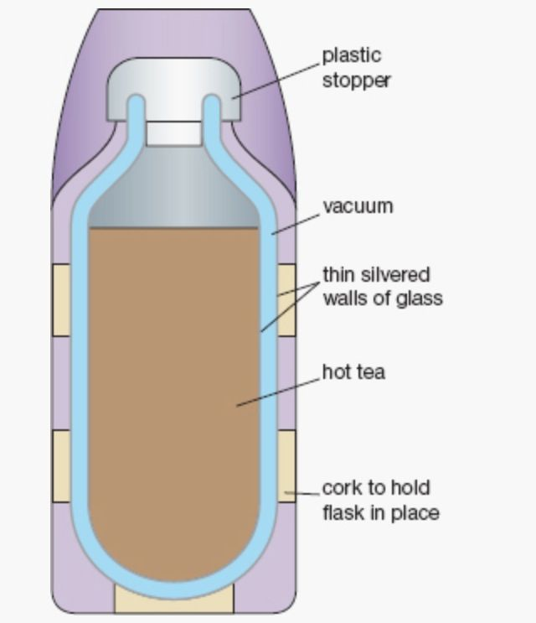
Vacuum:

Thin silvered walls of glass:

Cork to hold the flask in place:

☺ CONGRATULATIONS: ☺
YOU HAVE COMPLETED THE 1st Y11 PHYSICS TEST

